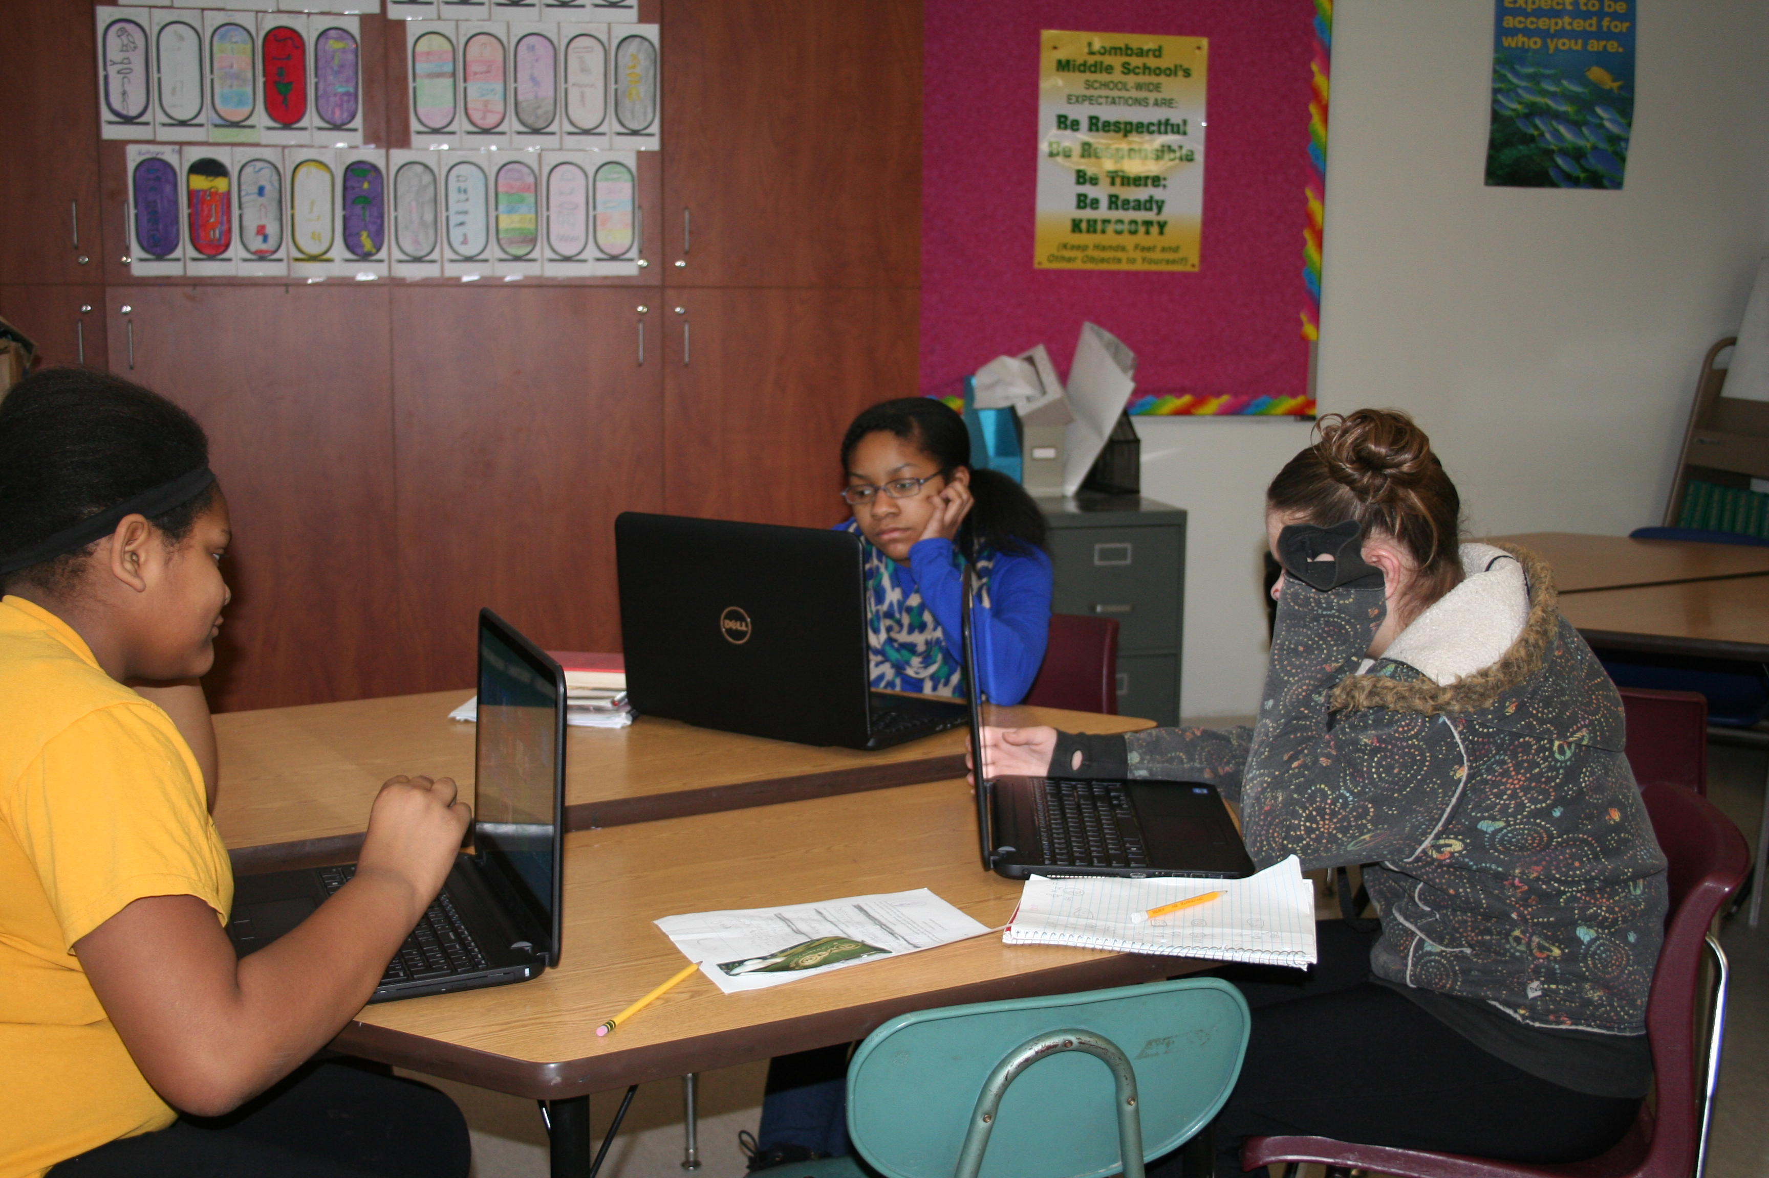  6th grade students at Lombard get their own computers!  Science Expectations:  Scientific Method & Lab Safety  - I can successfully conduct a scientific investigation as well as analyze and interpret data.  - I can identify lab equipment and can safely and properly use it. Energy  - I can describe basic energy transformations.  - I can identify the six basic forms of energy and explain how I am affected by them each day.  Waves & Electromagnetic Radiation  - I can describe the basic types of waves, their parts and their properties.  - I can compare wav e diagrams and interpret which wave has more energy and why.  - I can develop a model to represent how waves of different kinds can be reflected, absorbed or transmitted through various materials.  Motion & Forces  - I will develop a basic understanding of Newton’s three Laws of Motion.  - I can identify and reason which of Newton’s three laws of motion are at work in some every day actions  - I can predict what will happen to an object’s motion given the total forces acting on the object.  Matter & Its Interactions (Basic Chemistry)  - I can develop a model of an atom and give examples of where this element might be used in our everyday lives.  - I can read a chemical formula and create a model of a molecule.  - I can use indicators to determine a chemical change or a physical change in matter.  - I can read non-fiction text about synthetic and natural resources and compare and contrast the impact of each on society. |  |  | Homework  - Each teacher will be informing you of his/her policy concerning homework which is not completed on time. However, late homework may result in lower grade, homework notice, telephone call home, or further action by the teacher.  - The student will have as many days to make up the homework, as he/she was absent. It is the student's responsibility to find out what was missed and make arrangements to make up quizzes and tests.  - If a student will be gone for an extended period due to vacation, etc., teachers will be able to give an overview of material that will be covered. Specific written work, tests, and quizzes will be made up when the student returns.  Skyward Parent Access  - Skyward is a gradebook and communication system used by District 205 schools. It is imperative that parents/guardians sign up for access to this program through the school office. With skyward you may:  - Track the progress of your student.  - Communicate with teachers.  - Receive information that is happening at your student’s school.  Activities for 6th Graders  Sports:  - Soccer (Fall)  - Cross Country (Fall)  - Wrestling (Winter)  - Track (Spring)  Clubs:  - Drama  - Yearbook  - Student Council  - IMSA Fusion  - F.O.R.  - Geography Bowl  Important Links  www.lombard205.weebly.com  www.galesburg205.org  http://www.corestandards.org/  Lombard Middle School 6th Grade  1220 East Knox St.  Galesburg, IL 61401  (309)997-2004 |  |  | 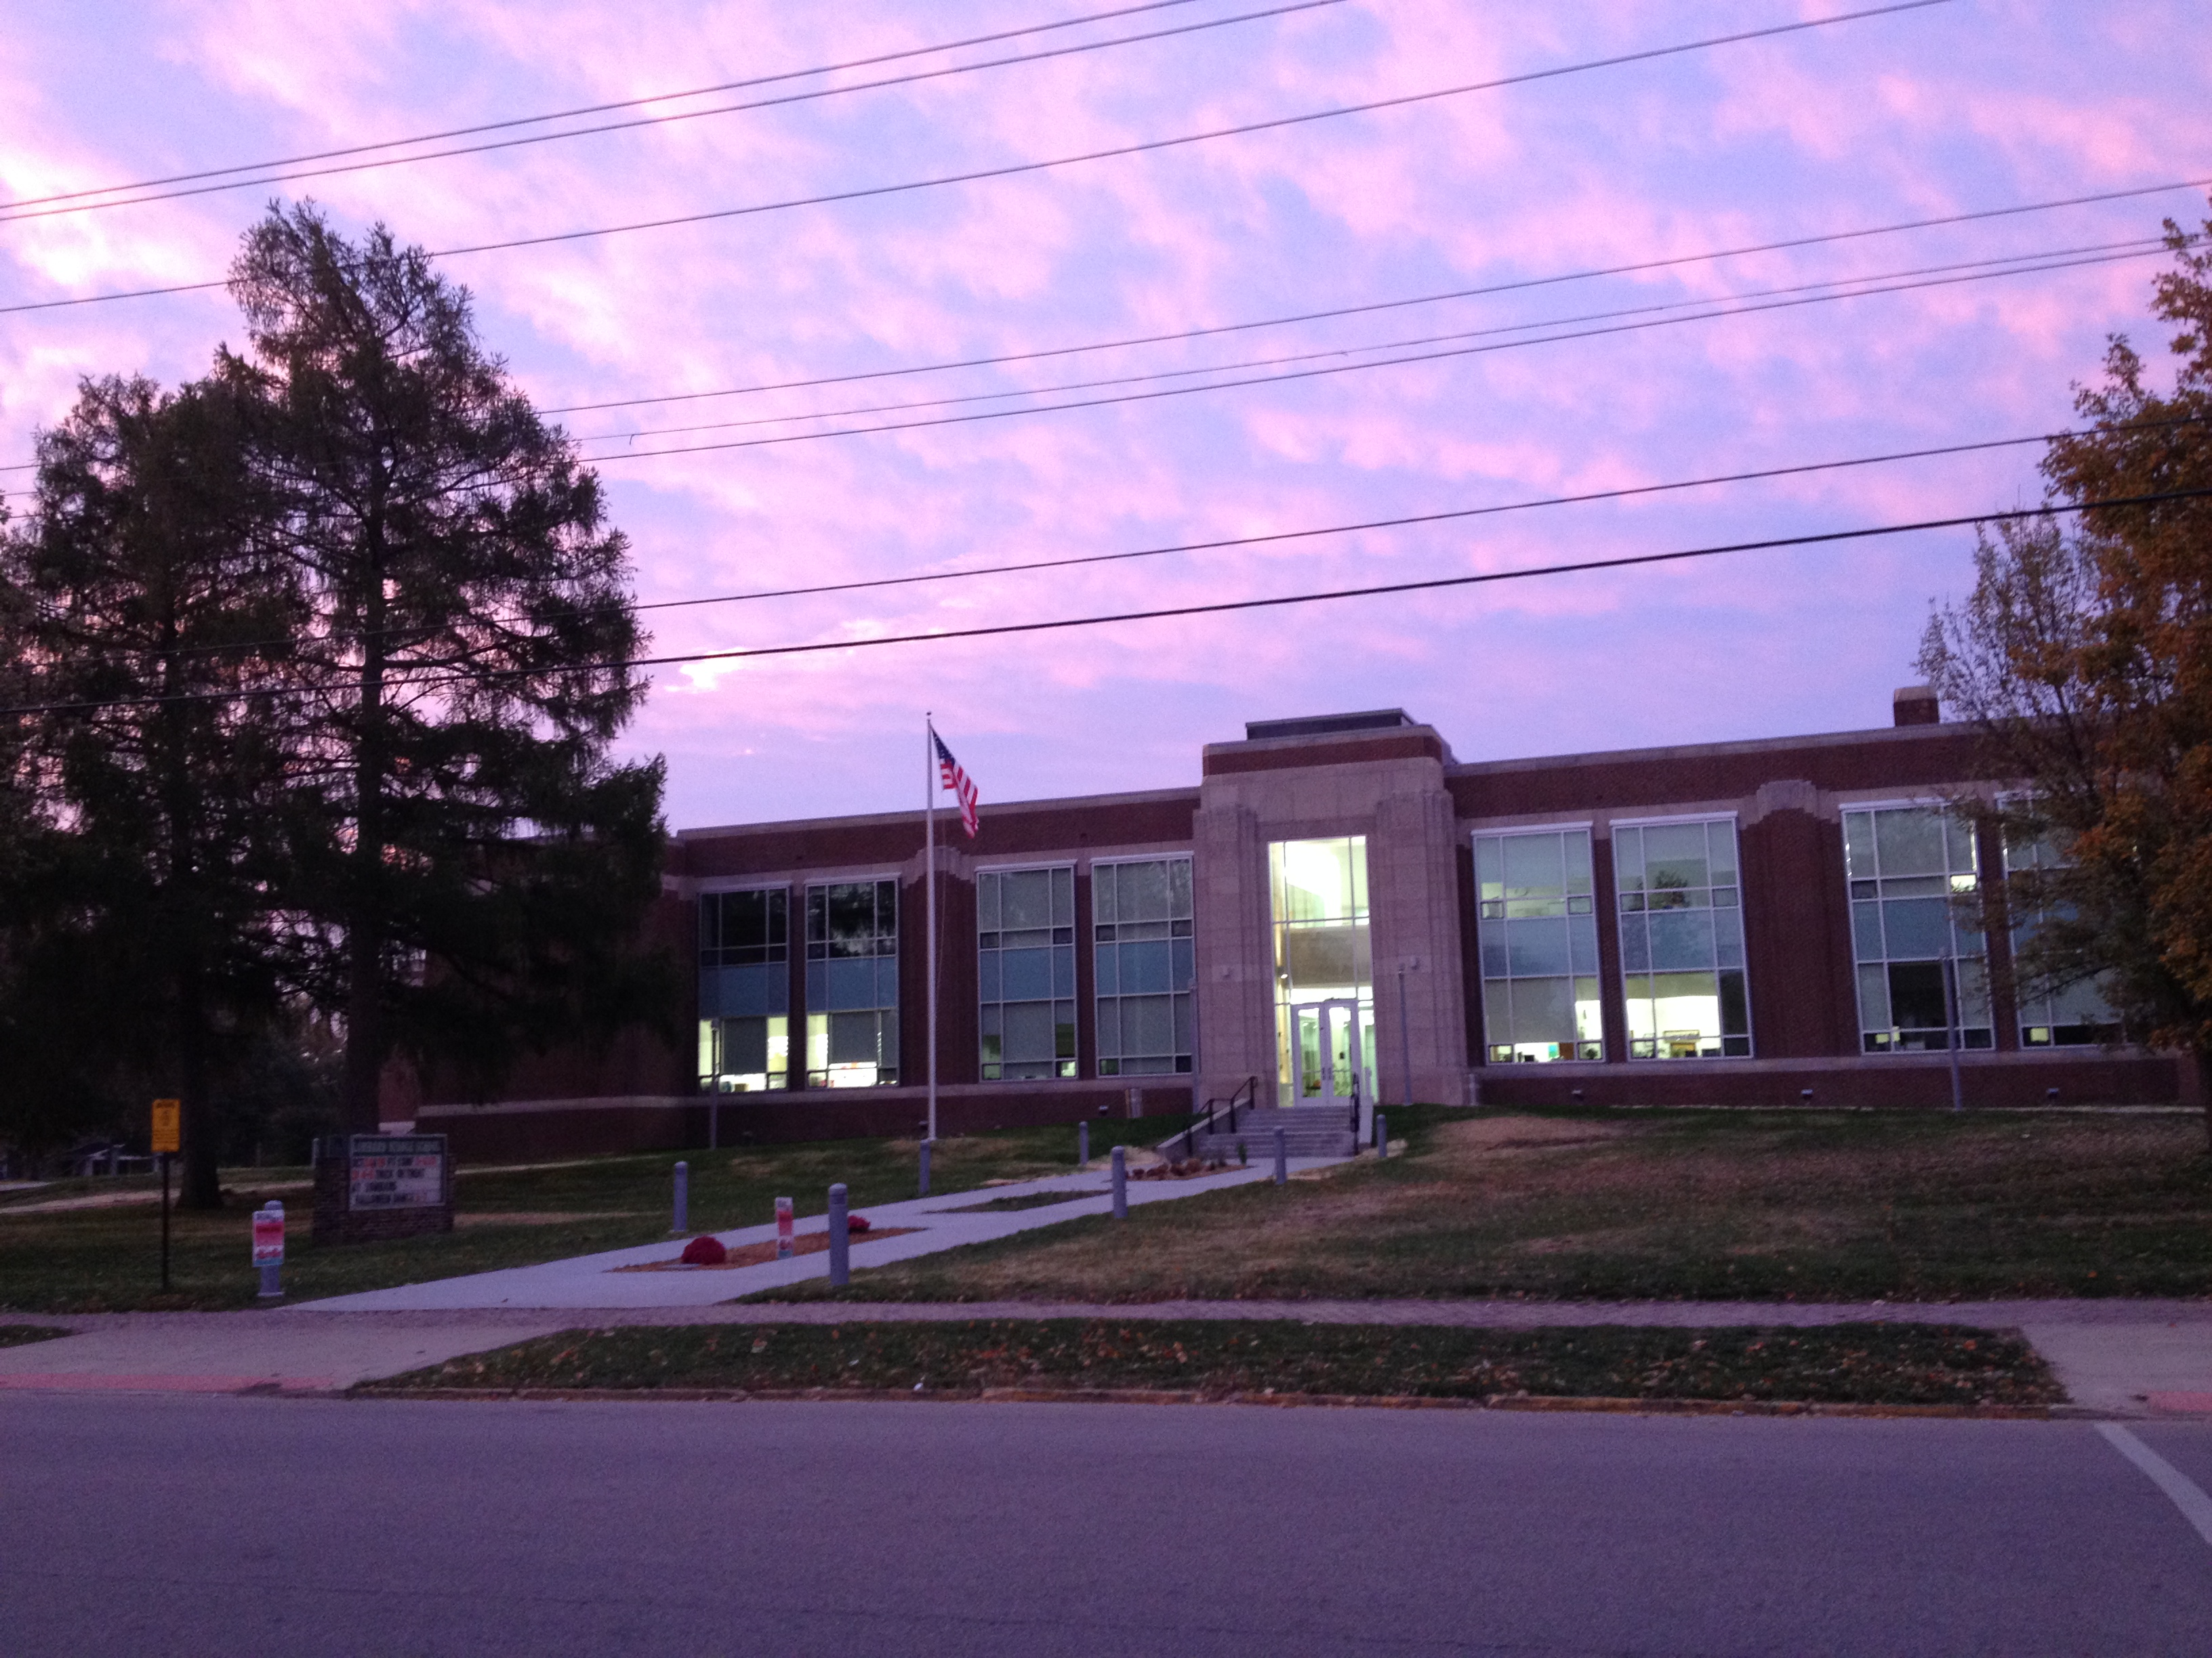  Lombard Middle School 6th Grade  - ……..Helping Students Achieve Their Dreams………….

English Expectations:  - Parts of Speech  - Grammar and Punctuation  - Sentence Structure  - Paragraph Structure  - Five Paragraph Essays  - Persuasive Writing  - Figurative Language  - Writing for an audience  - Descriptive Writing  - Research-Holocaust  - Poetry  6th grade students will:  - Use a multi-step writing process.  - Organize ideas using paragraphs.  - Demonstrate knowledge of the parts of speech.  - Use descriptive words to create a variety of sentence patterns.  - Use correct conventions (punctuation, capitalization, spelling, and grammar).  - Use technology to research and publish work.  Reading Expectations:  - I can read and comprehend text, including stories, dramas, poems, and nonfiction in the grades 6–8 text complexity range.  - I can describe how a particular story’s or drama’s plot unfolds.  - I can determine the meaning of words and phrases as they are used in a text, including figurative, technical meanings and connotative meanings  - I can identify point of view and author’s purpose in a text, and explain how an author develops the point of view of the narrator or speaker in a text.  - I can compare and contrast the experience of reading a story, drama, or poem to listening to or viewing an audio, video, or live version of the text  - I can compare and contrast texts in different forms or genres (e.g., stories and poems; historical novels and fantasy stories) and texts from different authors regarding similar topics.  - I can cite textual evidence  - I can determine a central idea of a text and provide a summary of the text.  - I can analyze in detail how a key individual, event, or idea is introduced, illustrated, and elaborated in a text.  - I can determine the meaning of words and phrases as they are used in a text, including figurative, connotative, and technical meanings.  - I can comprehend information presented in different media or formats as well as in words to develop an understanding of a topic or issue.  - I can comprehend an argument presented in text and determine if the claim is well supported or not.  - work. |  |  | - I can determine a central idea of a text and provide a summary of the text.  - I can analyze in detail how a key individual, event, or idea is introduced, illustrated, and elaborated in a text.  - I can determine the meaning of words and phrases as they are used in a text, including figurative, connotative, and technical meanings.  - I can comprehend information presented in different media or formats as well as in words to develop an understanding of a topic or issue.  - I can comprehend an argument presented in text and determine if the claim is well supported or not.  Math Expectations:  Lombard Middle School incorporates the focus of instruction as stated in the Common Core Standards for Math. Students use printed resources, data driven internet programs, and hands-on activities as tools to achieve success during the 6th grade year. Throughout the year, students will master the following concepts:  Ratios and Proportional Relationships- understand ratio concepts & use ratio reasoning to solve problems. Number System – apply & extend previous understandings of numbers. Expressions & Equations – apply & extend previous understandings of arithmetic to algebraic expressions. Geometry – solve real-world & math problems. Statistics & Probability – understanding of statistical variability.  Sixth Grade students will:  - use formulas to find area, volume, perimeter, and surface area graph, locate, identify points, and plot figures using ordered pairs in the coordinate plane  - apply and extend knowledge and skills to create geometric constructions using appropriate tools (tessellations, etc.)  - understand congruence, similarity, symmetry, reflections, and translations  - identify & understand geometric concepts in 2- dimensional & 3-dimensional shapes  - identify and construct a 3-dimensional object from a net  - understand and use the order of operations |  |  | - read, write, & evaluate algebraic expressions  - write equations to represent a situation and solve for the unknown quantity  - understand and use exponents  - model addition and subtraction with integers  - collect and organize data (line plot, frequency table, etc.)  - calculate and determine best use of mean, median, mode, and range  - understand, analyze, construct, and read graphs and spreadsheet data  - use diagrams and formulas to determine probability and use probability to formulate predictions  - . solve problems involving proportional reasoning  - identify and express ratios using appropriate notation, identify equivalent ratios, and explain ratios that represent a given situation  - understand decimals in real life estimate ad find percent’s  - understand terminating and repeating decimals  - convert decimals to percent’s and fractions  - understand and compute time schedules  - read, write, compare, and order decimals to the millionths place  - compute, estimate, and round to a given place value  - understand concepts involving simplification, mixed numbers, and improper fractions  - understand prime factorization  - use and convert within the standard and metric system of measurement  Social Studies Expectations:  - Mesopotamia  - Ancient Egypt  - Holidays Around the World  - Ancient Greece  - Middle Ages  6th grade students will:  - Demonstrate knowledge of key concepts of life in ancient society.  - Use technology to research and produce work.  - Collaborate on a multitude of projects.  - Discuss ancient civilizations and its role on present day society.

